

YAYASAN SASMITA JAYA

**UNIVERSITAS PAMULANG**

**Jl. Surya Kencana No. 1 Pamulang Telp (021)7412566, Fax. (021)7412566**

**Tangerang – Banten**

**UJIAN TENGAH SEMESTER**

**TAHUN AKADEMIK 2020-2021**

|  |  |
| --- | --- |
| Nama Mahasiswa : Yoni Santoso  NIM : 171011402025  Semester : 07 TPLE 007  Program Studi : Teknik Informatika | Mata Kuliah : Kecerdasan Buatan  Nama Dosen : Agung Perdananto S.Kom M.Kom  Hari/Tgl : Selasa, 12 Januari 2021  Kelas : Reguler C |

Berikut saya lampirkan Jawaban UAS dalam betuk :

* Link : https://github.com/YoniSant/Yoni-Santoso-171011402035-07TPLE007.git
* Source Code
* Screen Shoot Output

Dan saya lampirkan pula :

* Bukti pembayaran
* Kartu UAS

**SOURCE CODE :**

|  |
| --- |
| #!/usr/bin/env python |
|  |

|  |
| --- |
| # coding: utf-8 |
|  |

|  |
| --- |
|  |
|  |

|  |
| --- |
| # In[95]: |
|  |

|  |
| --- |
|  |
|  |

|  |
| --- |
|  |
|  |

|  |
| --- |
| # Yoni Santoso |
|  |

|  |
| --- |
| # 171011402035 |
|  |

|  |
| --- |
| # 07 TPLE 007 |
|  |

|  |
| --- |
| # UAS Kecerdasan Buatan |
|  |

|  |
| --- |
|  |
|  |

|  |
| --- |
| import pandas as pd |
|  |

|  |
| --- |
| import numpy as np |
|  |

|  |
| --- |
| import seaborn as sns |
|  |

|  |
| --- |
| get_ipython().run_line_magic('matplotlib', 'inline') |
|  |

|  |
| --- |
| import matplotlib.pyplot as plt |
|  |

|  |
| --- |
| import math |
|  |

|  |
| --- |
| import sklearn |
|  |

|  |
| --- |
|  |
|  |

|  |
| --- |
| #Menampilkan Hours dan Scores |
|  |

|  |
| --- |
|  |
|  |

|  |
| --- |
| general_data= pd.read_csv("student scores.csv") |
|  |

|  |
| --- |
| general_data.head(26) |
|  |

|  |
| --- |
|  |
|  |

|  |
| --- |
|  |
|  |

|  |
| --- |
| # In[53]: |
|  |

|  |
| --- |
|  |
|  |

|  |
| --- |
|  |
|  |

|  |
| --- |
| general_data.shape |
|  |

|  |
| --- |
|  |
|  |

|  |
| --- |
|  |
|  |

|  |
| --- |
| # In[92]: |
|  |

|  |
| --- |
|  |
|  |

|  |
| --- |
|  |
|  |

|  |
| --- |
| #Menampilkan Jumlah Data |
|  |

|  |
| --- |
|  |
|  |

|  |
| --- |
| print("#JUMLAH DATASET SAYA =" +str(len(general_data.index))) |
|  |

|  |
| --- |
|  |
|  |

|  |
| --- |
|  |
|  |

|  |
| --- |
| # In[91]: |
|  |

|  |
| --- |
|  |
|  |

|  |
| --- |
|  |
|  |

|  |
| --- |
| #Menampilkan Deskriptif Analisis |
|  |

|  |
| --- |
|  |
|  |

|  |
| --- |
| general_data.describe() |
|  |

|  |
| --- |
|  |
|  |

|  |
| --- |
|  |
|  |

|  |
| --- |
| # In[90]: |
|  |

|  |
| --- |
|  |
|  |

|  |
| --- |
|  |
|  |

|  |
| --- |
| #visualisasi hasil plot hours vs scores |
|  |

|  |
| --- |
|  |
|  |

|  |
| --- |
| general_data.plot(x='Hours', y='Scores', style='o') |
|  |

|  |
| --- |
| plt.title('Hours vs Scores') |
|  |

|  |
| --- |
| plt.xlabel('Hours Studied') |
|  |

|  |
| --- |
| plt.ylabel('Percentage Score') |
|  |

|  |
| --- |
| plt.show() |
|  |

|  |
| --- |
|  |
|  |

|  |
| --- |
|  |
|  |

|  |
| --- |
| # In[57]: |
|  |

|  |
| --- |
|  |
|  |

|  |
| --- |
|  |
|  |

|  |
| --- |
| x = general_data.iloc[:, :-1].values |
|  |

|  |
| --- |
| y = general_data.iloc[:, :1].values |
|  |

|  |
| --- |
|  |
|  |

|  |
| --- |
|  |
|  |

|  |
| --- |
| # In[58]: |
|  |

|  |
| --- |
|  |
|  |

|  |
| --- |
|  |
|  |

|  |
| --- |
| from sklearn.model_selection import train_test_split |
|  |

|  |
| --- |
| x_train, x_test, y_train, y_test = train_test_split(x, y, test_size=0.2, random_state=0) |
|  |

|  |
| --- |
|  |
|  |

|  |
| --- |
|  |
|  |

|  |
| --- |
| # In[80]: |
|  |

|  |
| --- |
|  |
|  |

|  |
| --- |
|  |
|  |

|  |
| --- |
| from sklearn.linear_model import LinearRegression |
|  |

|  |
| --- |
| linreg = LinearRegression() |
|  |

|  |
| --- |
| linreg.fit(x_train, y_train) |
|  |

|  |
| --- |
|  |
|  |

|  |
| --- |
|  |
|  |

|  |
| --- |
| # In[61]: |
|  |

|  |
| --- |
|  |
|  |

|  |
| --- |
|  |
|  |

|  |
| --- |
| print(regressor.intercept_) |
|  |

|  |
| --- |
|  |
|  |

|  |
| --- |
|  |
|  |

|  |
| --- |
| # In[62]: |
|  |

|  |
| --- |
|  |
|  |

|  |
| --- |
|  |
|  |

|  |
| --- |
| print(regressor.coef_) |
|  |

|  |
| --- |
|  |
|  |

|  |
| --- |
|  |
|  |

|  |
| --- |
| # In[64]: |
|  |

|  |
| --- |
|  |
|  |

|  |
| --- |
|  |
|  |

|  |
| --- |
| y_pred = regressor.predict(x_test) |
|  |

|  |
| --- |
|  |
|  |

|  |
| --- |
|  |
|  |

|  |
| --- |
| # In[89]: |
|  |

|  |
| --- |
|  |
|  |

|  |
| --- |
|  |
|  |

|  |
| --- |
| #visualisasi hours vs scores |
|  |

|  |
| --- |
|  |
|  |

|  |
| --- |
| sns.pairplot(general_data) |
|  |

|  |
| --- |
|  |
|  |

|  |
| --- |
|  |
|  |

|  |
| --- |
| # In[88]: |
|  |

|  |
| --- |
|  |
|  |

|  |
| --- |
|  |
|  |

|  |
| --- |
| #visualisasi hasil training set |
|  |

|  |
| --- |
|  |
|  |

|  |
| --- |
| plt.scatter(x_train, y_train, color = 'red') |
|  |

|  |
| --- |
| plt.plot(x_train, regressor.predict(x_train), color = 'blue') |
|  |

|  |
| --- |
| plt.title('Hours vs Scores') |
|  |

|  |
| --- |
| plt.xlabel('Hours studied') |
|  |

|  |
| --- |
| plt.ylabel('Percentage Score') |
|  |

|  |
| --- |
| plt.show() |
|  |

|  |
| --- |
|  |
|  |

|  |
| --- |
|  |
|  |

|  |
| --- |
| # In[87]: |
|  |

|  |
| --- |
|  |
|  |

|  |
| --- |
|  |
|  |

|  |
| --- |
| #visualisasi hasil test set |
|  |

|  |
| --- |
|  |
|  |

|  |
| --- |
| plt.scatter(x_test, y_test, color = 'red') |
|  |

|  |
| --- |
| plt.plot(x_train, regressor.predict(x_train), color = 'blue') |
|  |

|  |
| --- |
| plt.title('Hours vs Scores') |
|  |

|  |
| --- |
| plt.xlabel('Hours studied') |
|  |

|  |
| --- |
| plt.ylabel('Percentage Score') |
|  |

|  |
| --- |
| plt.show() |
|  |

|  |
| --- |
|  |
|  |

|  |
| --- |
|  |
|  |

**Screen Shoot Output :**

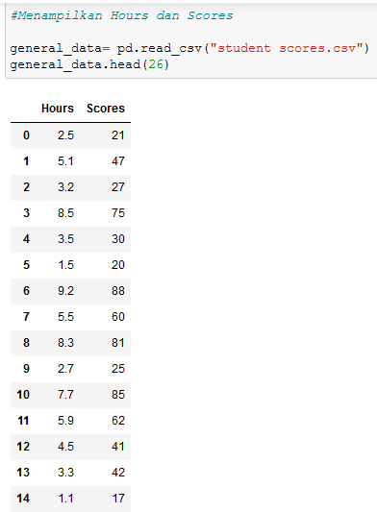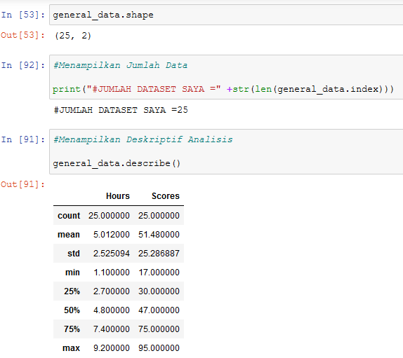

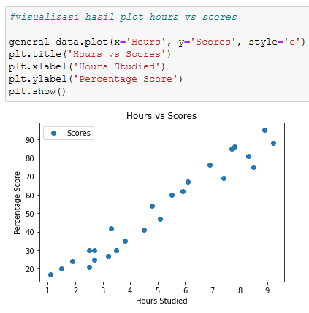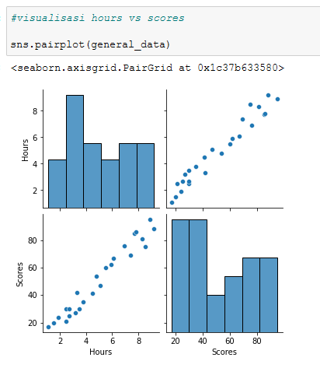

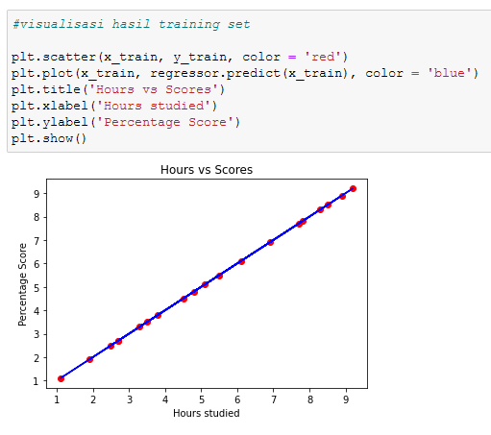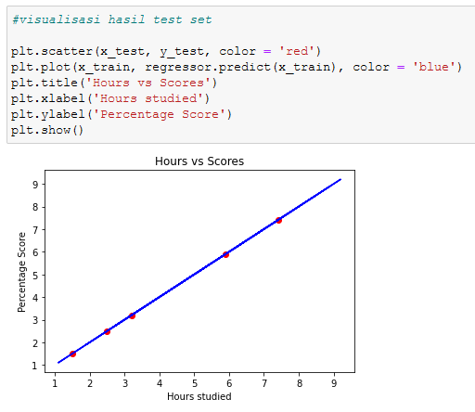

**Bukti Pembayaran :**

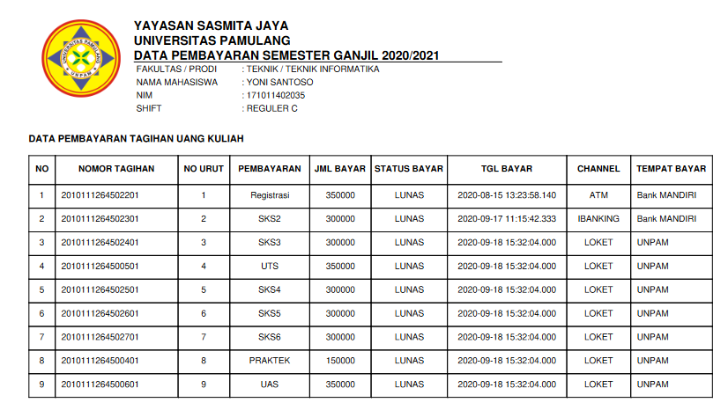

**Kartu Ujian Akhir Semester :**

